Automated Attack Orchestration Lab Report

1. Objective
The objective of this lab was to simulate and automate a multi-phase cyber attack scenario using MITRE Caldera and Red Team Automation (RTA). The exercise focused on automated adversary emulation, attack orchestration, and telemetry monitoring using ATT&CK techniques.

2. Tools Used
• MITRE Caldera – Automated adversary emulation
• Red Team Automation (RTA) – ATT&CK technique automation
• Kibana/Elasticsearch – Monitoring and visualization
• Linux Terminal – Agent execution and control

3. Methodology
The lab involved configuring adversary profiles, deploying agents, selecting ATT&CK techniques, launching operations, and validating telemetry through centralized monitoring dashboards.

4. Step-by-Step Execution

Step 1 – Launching MITRE Caldera
MITRE Caldera was initialized successfully in the Linux environment and plugins were loaded correctly.
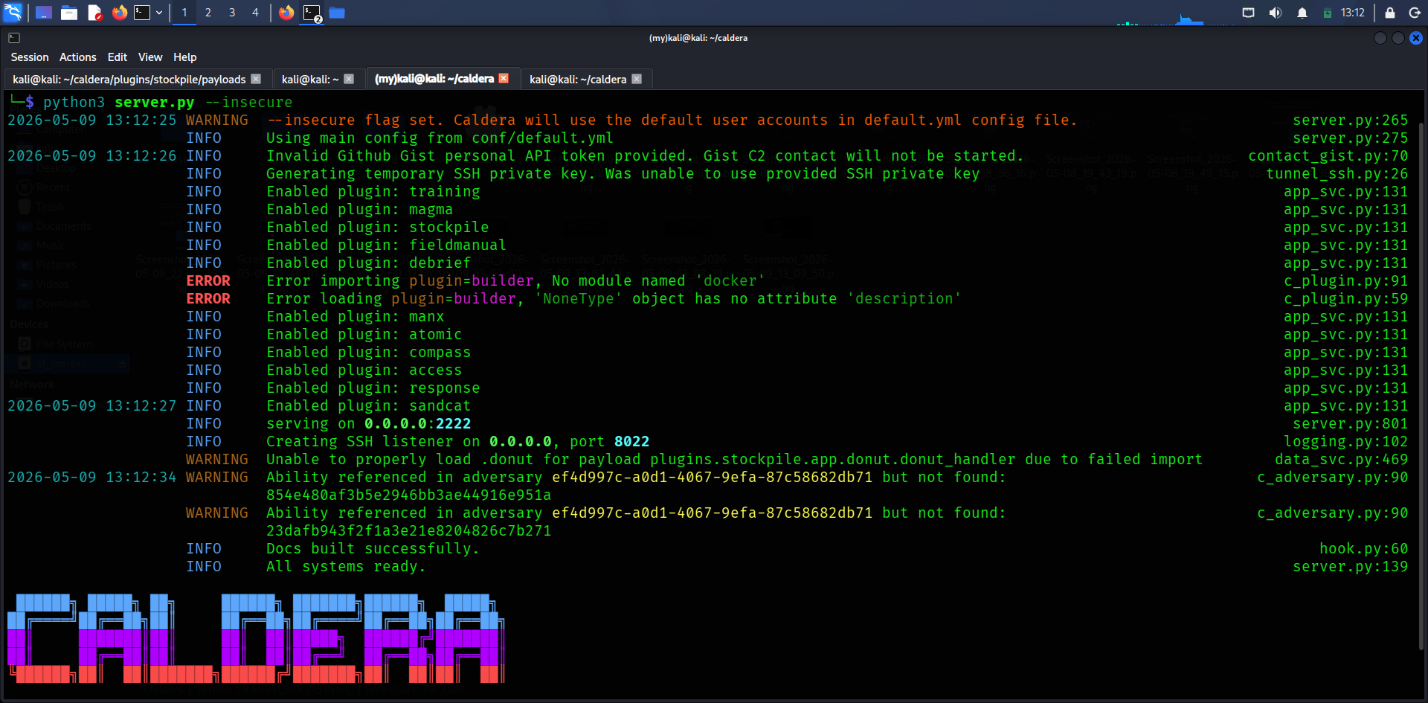

Step 2 – Accessing the Dashboard
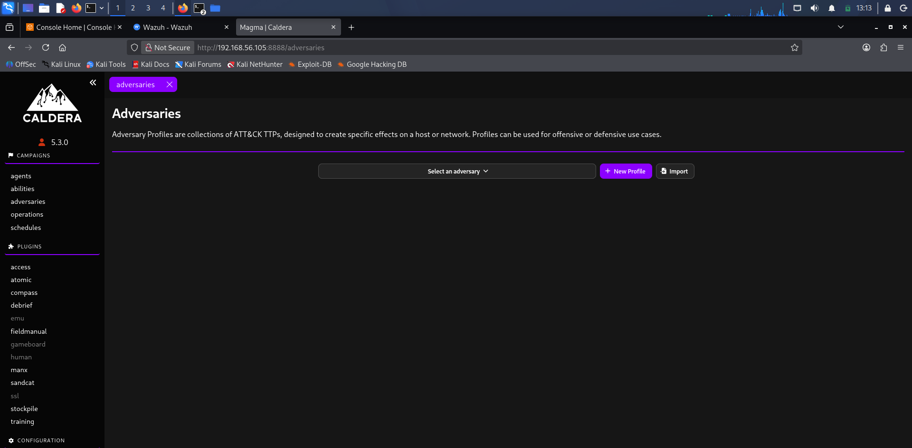
The Caldera dashboard was accessed through the web interface to manage operations, agents, and adversary profiles.

Step 3 – Creating Adversary Profiles
Adversary profiles were configured to define attack chains and ATT&CK-based abilities.
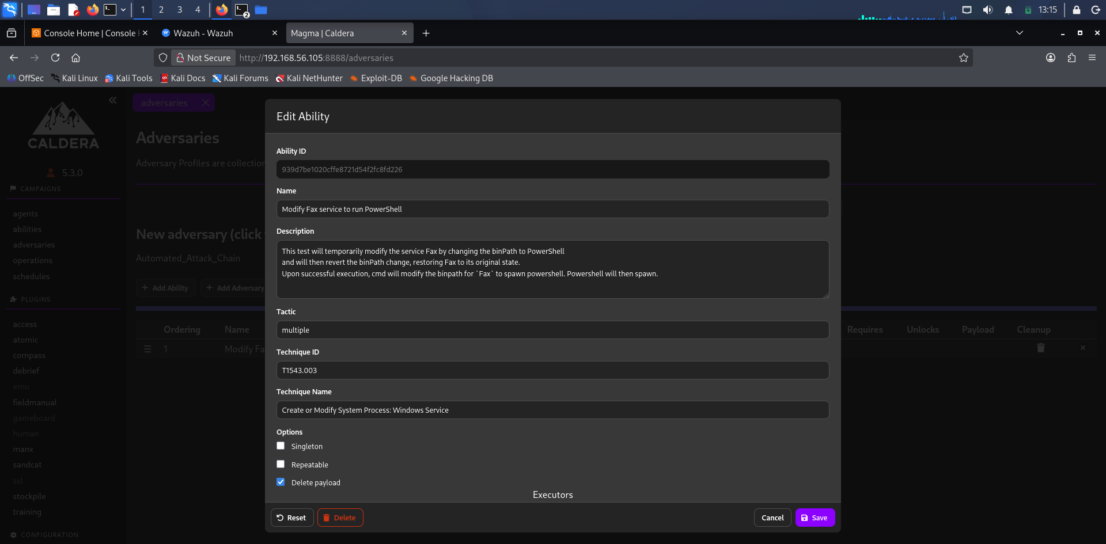

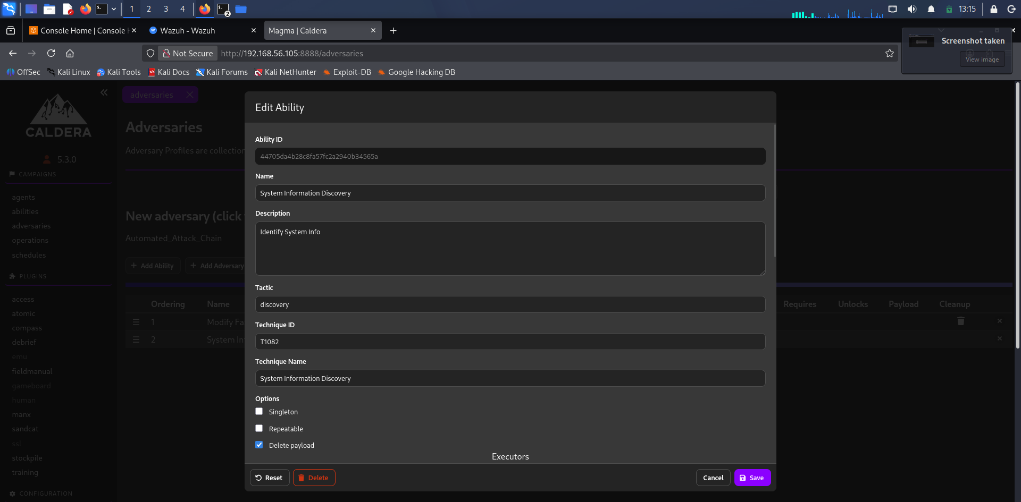

Step 4 – ATT&CK Technique Selection
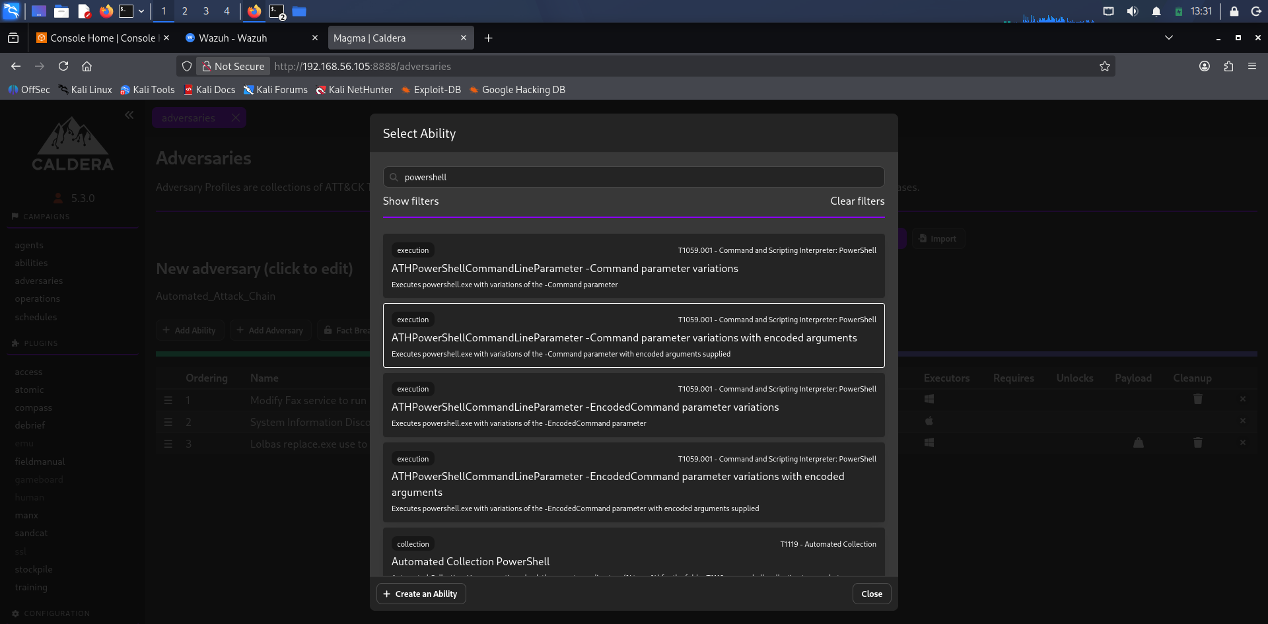
Multiple ATT&CK techniques were selected for execution, persistence, discovery, and exploitation simulation.
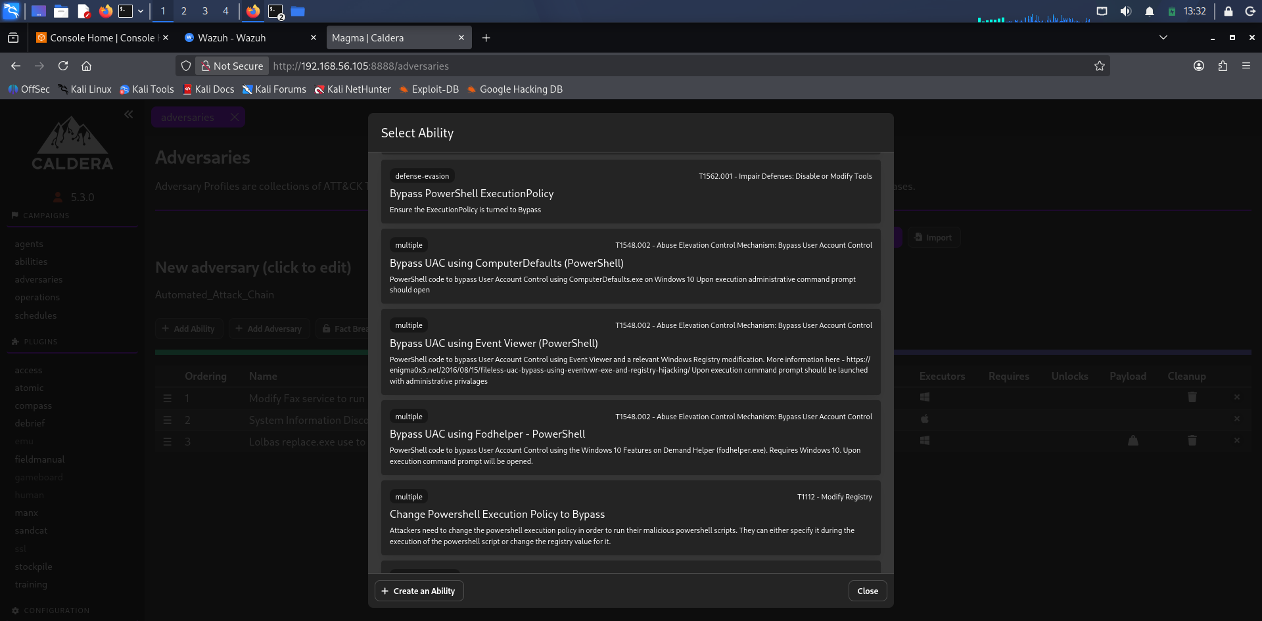

Step 5 – Reviewing Abilities
The available attack abilities and execution modules were reviewed before launching the operation.
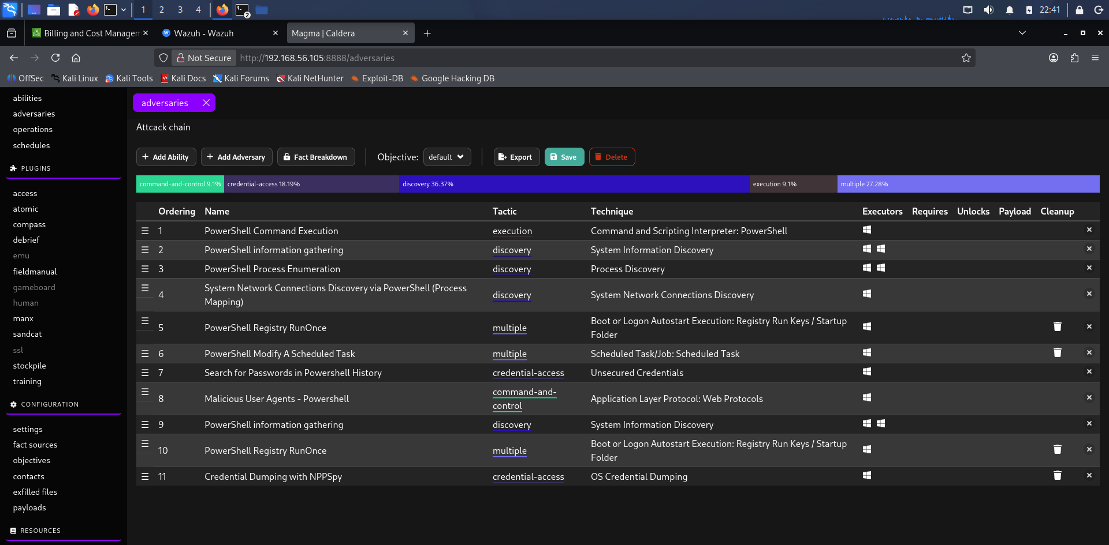

Step 6 – Agent Registration
Agents were deployed and successfully registered with the Caldera server.

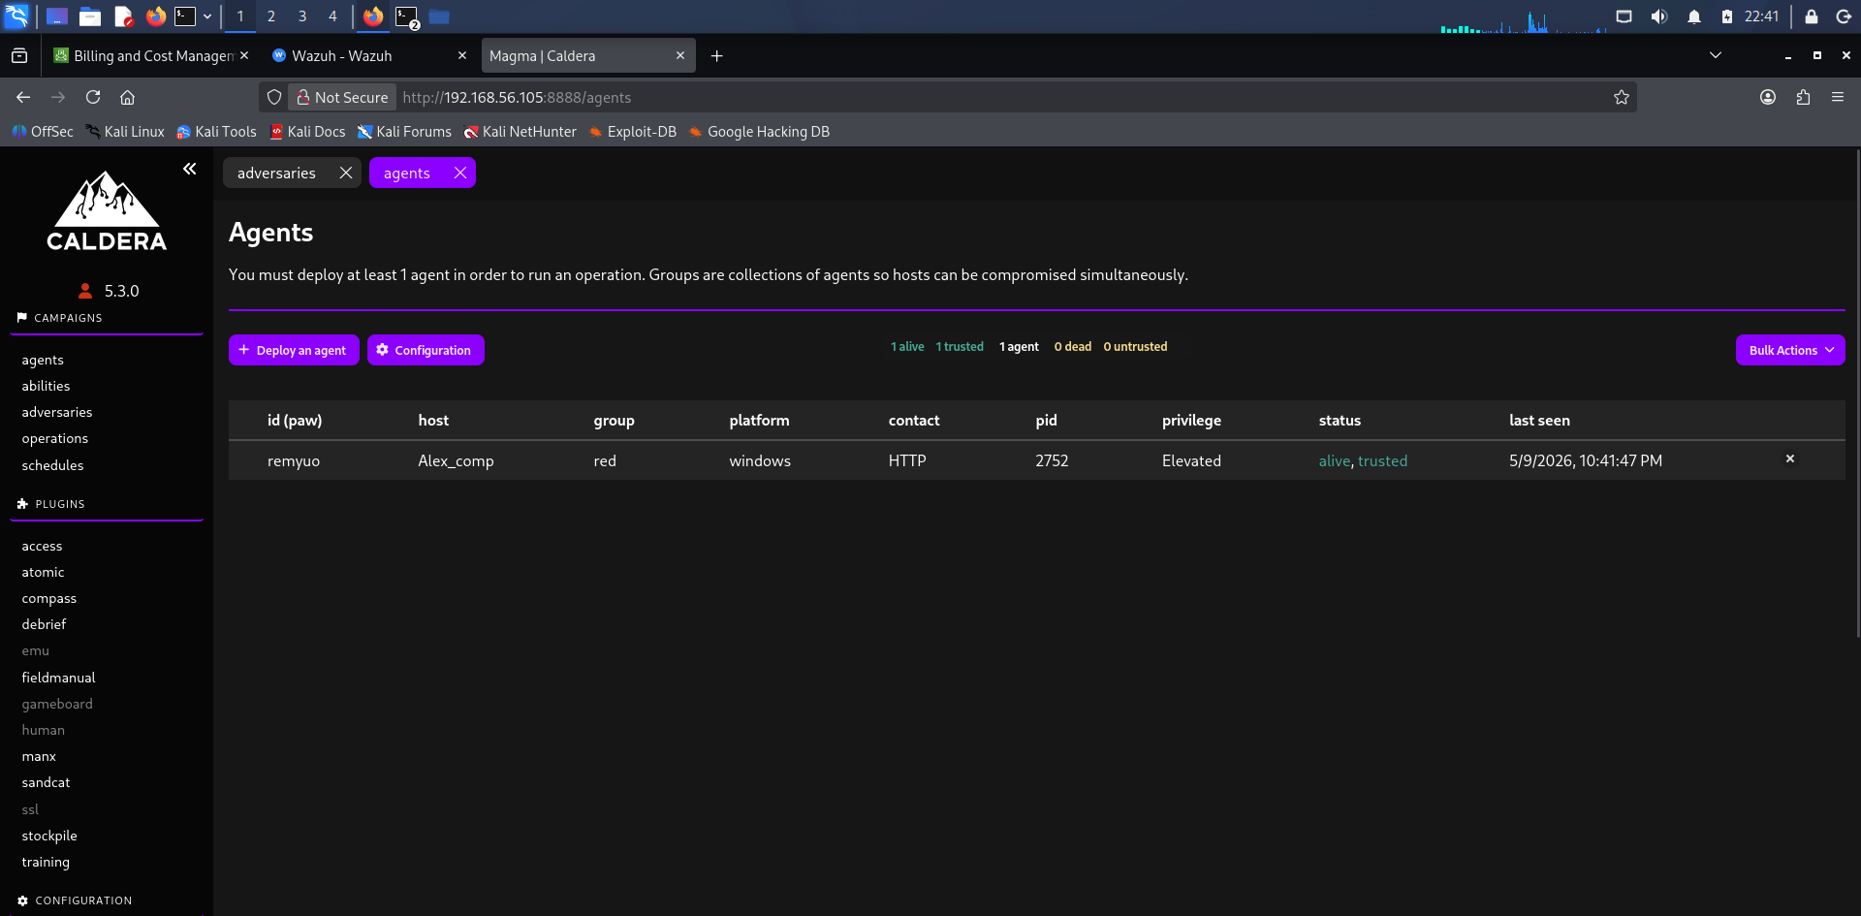

Step 7 – Operation Execution
The automated operation was launched using the configured adversary profile, executing multiple attack stages.

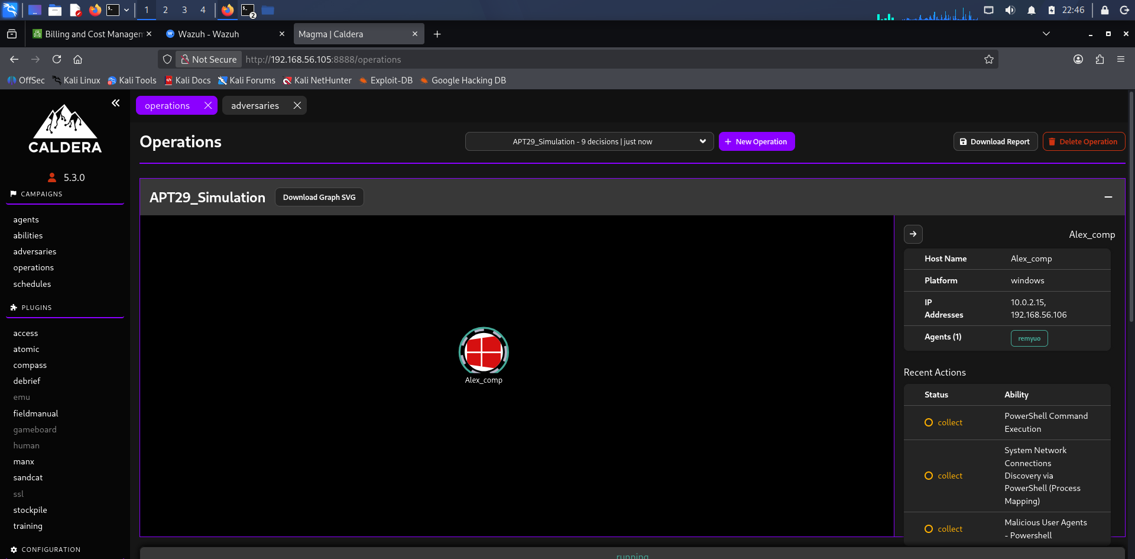

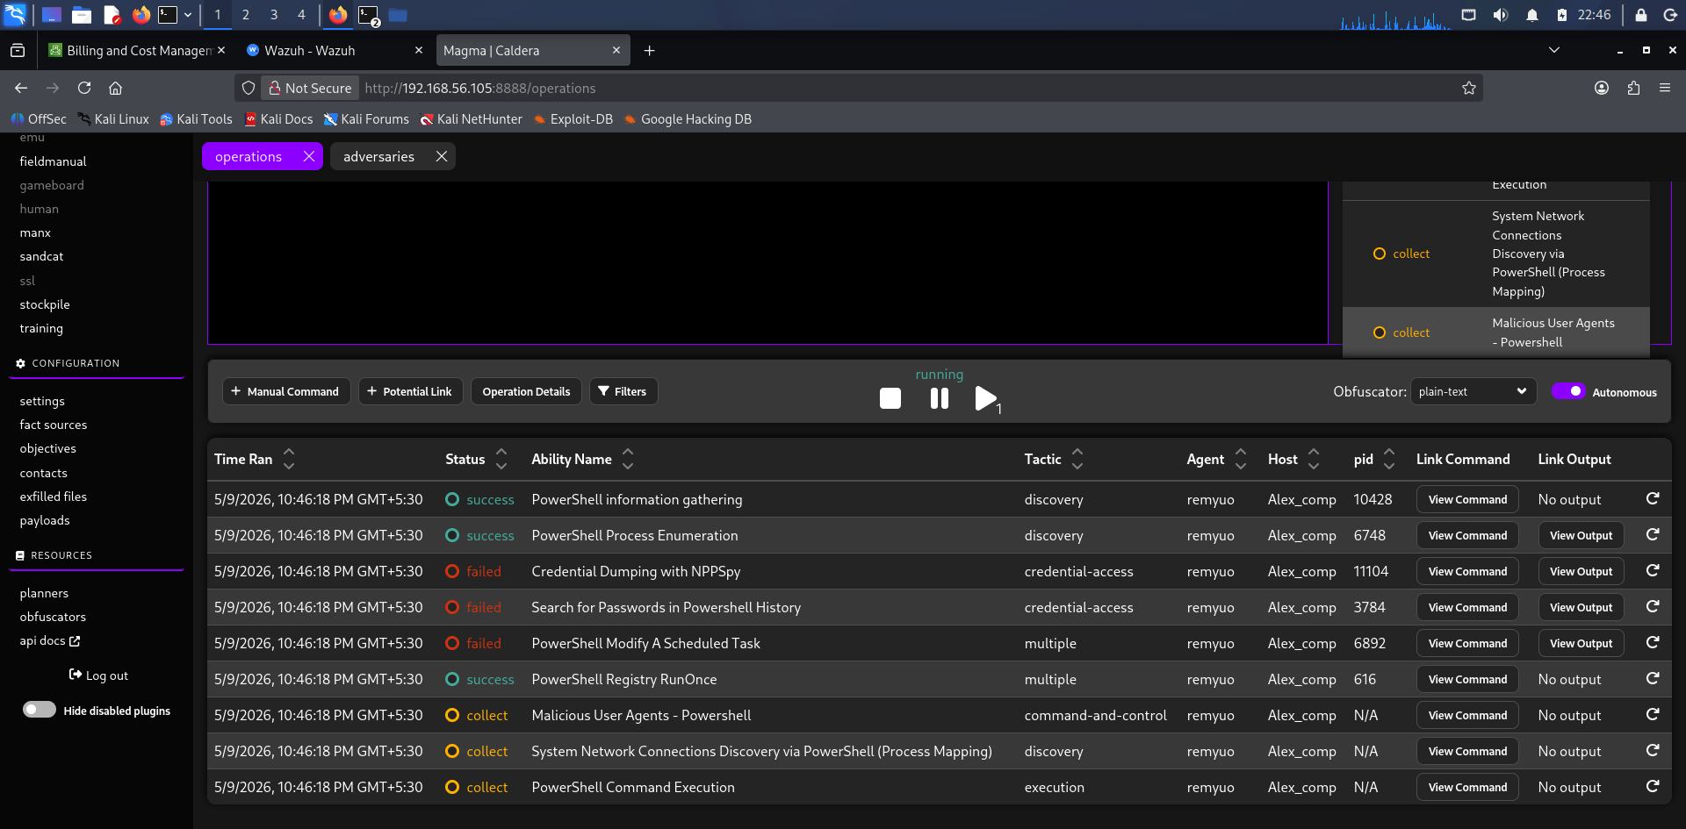

Step 8 – Monitoring Logs and Events
Kibana and Elasticsearch dashboards were used to monitor telemetry, logs, and attack events.

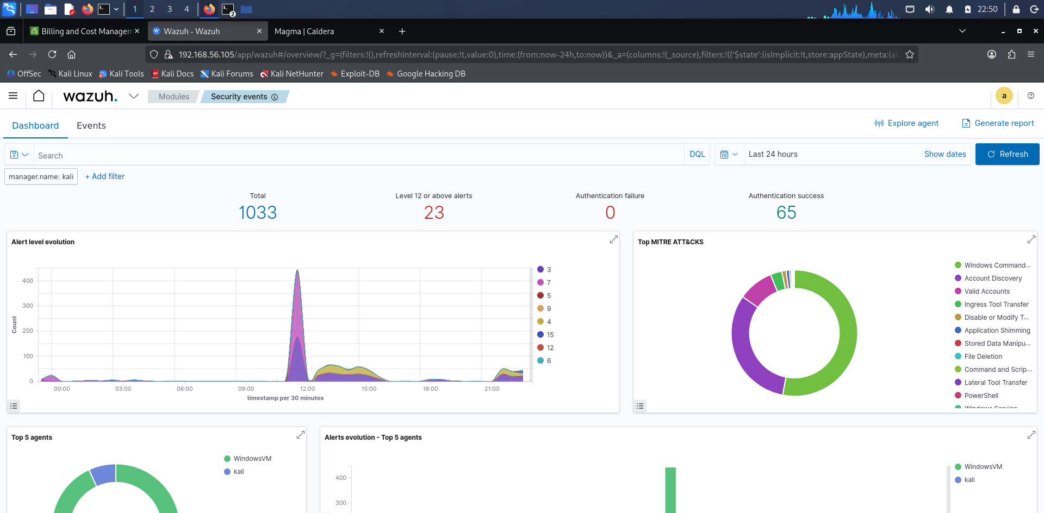

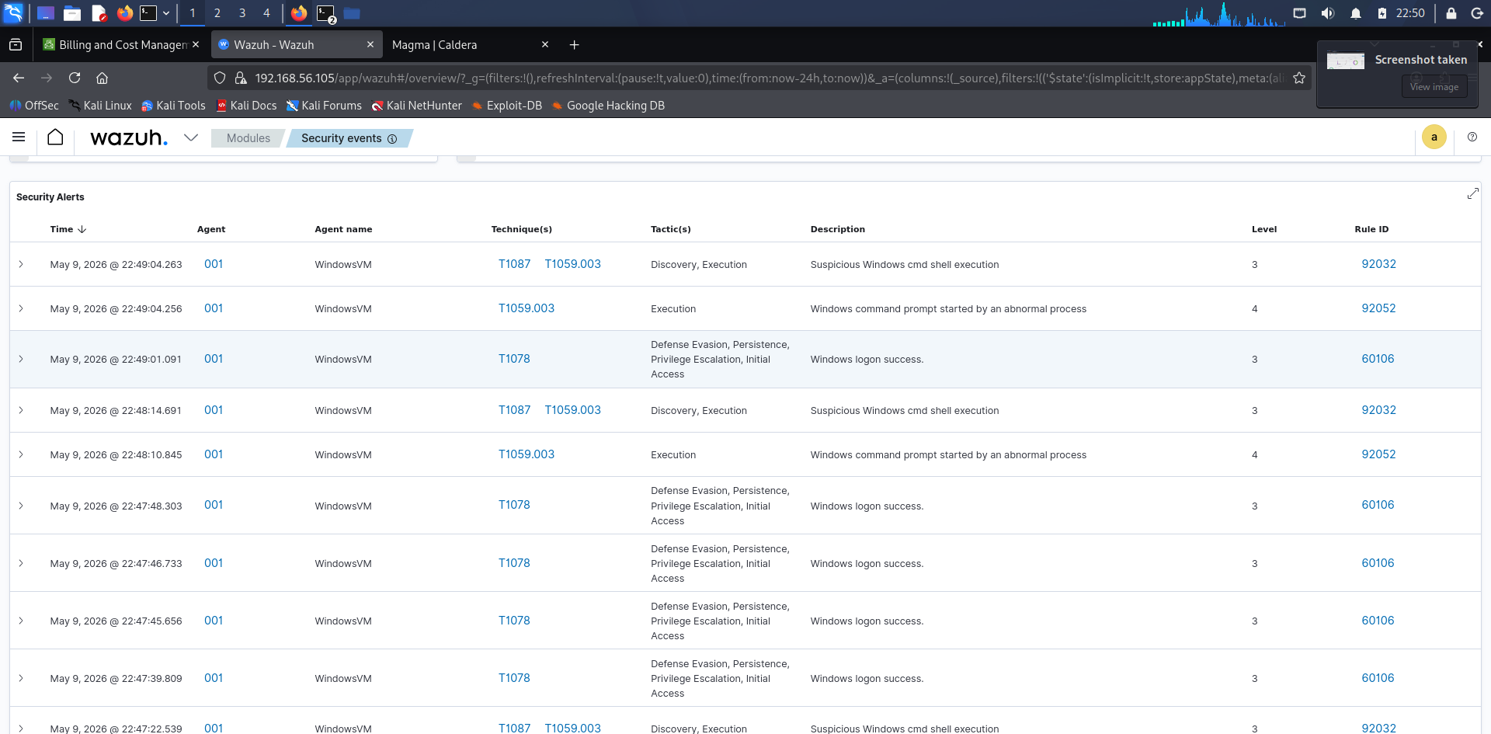

Step 9 – Reviewing Attack Artifacts
Detailed attack traces and event information were reviewed for validation.
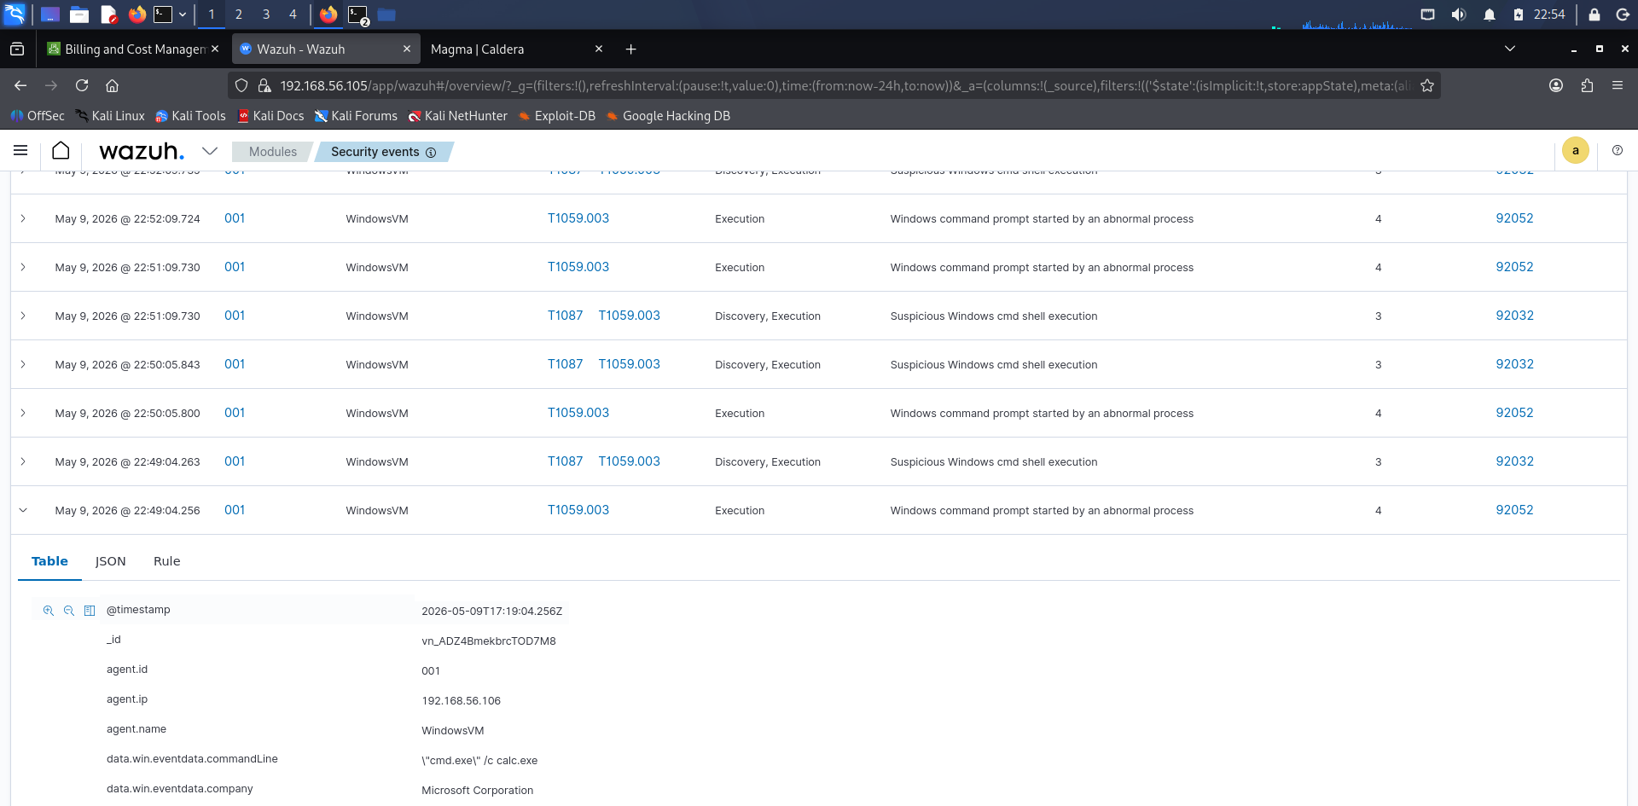
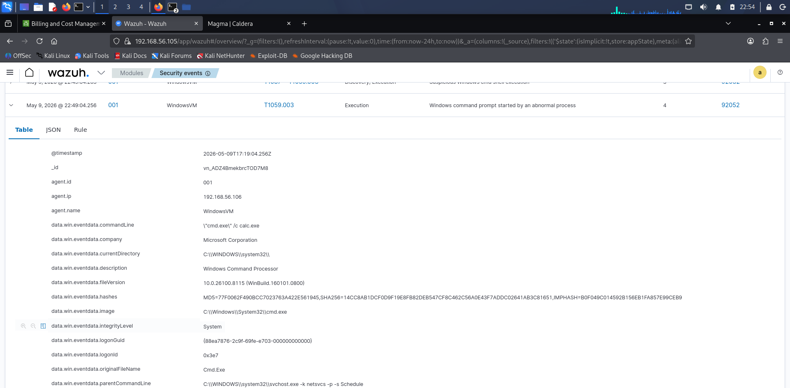

Step 10 – Final Validation
Final dashboards confirmed successful orchestration and telemetry collection.
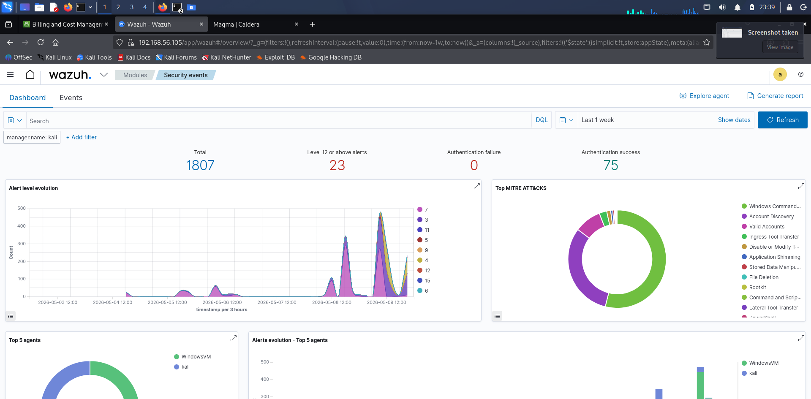

5. Attack Orchestration Table

Phase | TTP | Tool Used | Notes
Initial Access | T1566 | Caldera | Simulated phishing access
Execution | T1059 | Caldera | Automated command execution
Persistence | T1547 | Caldera | Persistence simulation
Discovery | T1082 | RTA | System discovery
Credential Access | T1003 | RTA | Credential dumping simulation
Exploitation | T1190 | Caldera | Automated RCE
Exfiltration | T1041 | Caldera | Simulated exfiltration

6. Results
The automated orchestration successfully executed multiple ATT&CK techniques. Agents communicated correctly with the server, operations were completed successfully, and telemetry was captured through Kibana dashboards.

7. Challenges Faced
• Agent communication delays
• Ability execution issues
• Telemetry indexing delays
• Configuration complexity

8. Security Recommendations
• Deploy centralized log monitoring
• Use EDR for behavioral detection
• Monitor abnormal process execution
• Validate detections using ATT&CK simulations

9. Orchestration Summary
This lab demonstrated automated attack orchestration using MITRE Caldera and Red Team Automation. Multiple ATT&CK techniques were executed through automated operations, including execution, persistence, discovery, and exploitation phases. Telemetry and logs were monitored using Kibana, validating successful adversary emulation, centralized monitoring, and multi-stage attack simulation.

10. Conclusion
The lab successfully demonstrated automated adversary emulation using MITRE Caldera. The exercise provided practical exposure to ATT&CK-based orchestration, telemetry analysis, operation execution, and centralized monitoring within a controlled lab environment.

